**Assignment**

Create Rails Application to display a list of users with details and allow inline editing. Page should have following fields

ID

First Name (textbox)

Last Name (textbox)

DOB (Datetime)

Status (Select options with values Active/InActive)

**Specifications:**

Rails >= 7.0.4

Ruby >= 3.2.3

Note:

You can any available inline editing gem(That supports Ruby >= 3.2.3)

Write test cases to test functionality

Step1:

When a user enters “https://localhost:3000”, it should display the page below.

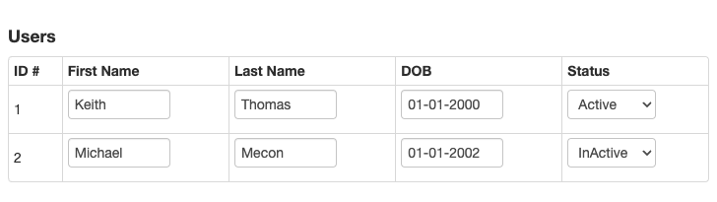

Step2:

When the user changes First Name(or any other fields) and tab out, it should update the values. If there are any errors(such as invalid format for DOB) then it should not update that value and display error(either message at the top of the page or make the border of the field to be red)

